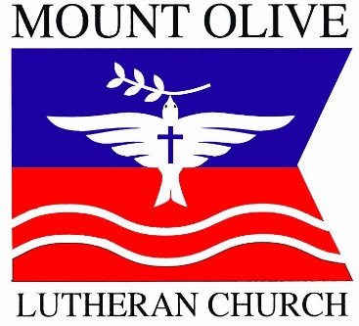
Mt. Olive Lutheran Church
5218 Bartlett Blvd, Mound, MN 55364
Pastor Michael Michalk 952-472-2756
Church membership information
Please save this document to your computer with your name as the file name. After entering the information requested below, please return the document to the church office by sending as an email attachment, or print and submit a paper copy. Thank you!
- Title: Click here to enter text.
- First name: Click here to enter text.
- Middle name: Click here to enter text.
- Last name: Click here to enter text.
- Suffix: Click here to enter text.
- Preferred name: Click here to enter text.
- Maiden/birth name: Click here to enter text.
- Current address: Click here to enter text.
- Other address: Click here to enter text.
- Dates to use other address: Click here to enter text.
- Home phone: Click here to enter text.
- May we list your home phone in church directory (Y/N): Choose yes or no from drop-down list.
- Cell phone: Click here to enter text.
- May we list your cell phone in church directory (Y/N): Choose yes or no from drop-down list.
- Email address: Click here to enter text.
- May we list your email in church directory (Y/N): Choose yes or no from drop-down list.
- Work phone: Click here to enter text.
- May we list your work phone in church directory (Y/N): Choose yes or no from drop-down list.
- Other contact information: Click here to enter text.
- May we list your other contact information in church directory (Y/N): Choose yes or no from drop-down list.
- The best way to contact me is by: Click here to enter text.
- Birthdate: Click here to enter text.
- Place of birth: Click here to enter text.
- Sex: M/F
- Baptized (Y/N): Choose yes or no from drop-down list.
- Baptism date: Click here to enter text.
- Where were you baptized? Click here to enter text.
- Confirmed (Y/N): Choose yes or no from drop-down list.
- Confirmation date: Click here to enter text.
- Where were you confirmed? Click here to enter text.
- First communion date: Click here to enter text.
- Member of Mt. Olive (Y/N): Choose yes or no from drop-down list.
- Date you became a member of Mt. Olive: Click here to enter text.
- If transferring from another LCMS congregation, please give us the name and address of that congregation here: Click here to enter text.
- Other church background: Click here to enter text.
- Ethnic origin: Click here to enter text.
- What is your role in your household? Choose an item.
- Marital status: Click here to enter text.
- Wedding date: Click here to enter text.
- Where were you married? Click here to enter text.
- Name of spouse (spouse should complete separate form): Click here to enter text.
- # of children (each child should complete separate form): Click here to enter text.
- Occupation: Click here to enter text.
- Employer name/address: Click here to enter text.
- Military service and/or current status: Click here to enter text.
- Education level: Click here to enter text.
- Current school: Click here to enter text.
- Current grade level: Click here to enter text.
- Sunday School grade: Click here to enter text.
- I am interested in the following activities: Click here to enter text.
- I have the following skills, talents, and/or spiritual gifts that I would like to share: Click here to enter text.
- I have the following training (include date completed): Click here to enter text.

